Math 10

Lesson 4–5 Answers

**Lesson Questions**

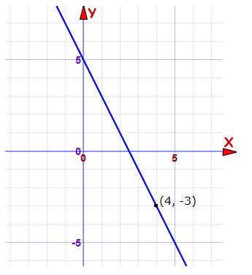**Question 1**





**Question 2**

a) 

–4

2

4

–4

–2

2

4

–2

*x*

*y*

(2, –1)

The graph has a slope of  and goes through the point (2, –1).

b) Graph the equation.

**Question 3**

Write an equation in standard form for the following linear equations:

a) passes through S(2, –3) and has a slope of 3.



b) passes through M(–4, 3) and N(2, 7)



**Question 4**

*x*-intercept of 4 → (4, 0)

*y*-intercept of –2 → (0, –2)

First calculate the slope: Then use the slope-point formula:





**Assignment**

1. a) 

b) 

c) 

d) *y* + 8 = 0 , or *y* = –8

2. Equations may be written in different forms.

a) i) *y* – 4 = –(*x* + 2) ii) *y –* 3 = (*x* – 3)

iii) *y* + 2 = (*x* + 4) iv) *y* + 2 = –(*x* – 1)

b) i) ; *x*-intercept: 1; *y*-intercept:

ii) ; *x*-intercept: –; *y*-intercept: 

iii) ; *x*-intercept: 2; *y*-intercept: –

iv) ; *x*-intercept: ; *y*-intercept: 

3. a) *y* – 2 = 2(*x* + 1)

b) *y* – 2 = (*x* – 1)

c) *y* – 1 = –(*x* – 2)

4. Coordinates may vary. For example:

a) Slope: –4; (1, 5)

b) Slope: 3; (8, –7)

c) Slope: 1; (–15, –11)

d) Slope: 5; (2, 0)

e) Slope:  ; (–3, –6)

f) Slope: – ; (–16, 21)

5. Slope-point forms of equations may vary. For example:

a) *y* – 1 = 2(*x* – 1) , or *y –* 5 = 2(*x* + 2) ;

b) *y* + 2 = –(*x* – 5) , or *y* – 7 = –(*x* + 4) ; 

c) *y* – 8 = 3(*x* – 2) , or *y* + 7 = 3(*x* + 3) ; 

d) *y* + 5 = –2(*x* + 5) , or *y* + 1 = –2(*x* + 7) ; 

6. Different variables may be used.

a) Let *s* be the speed of sound and *t* be the air temperature:

*s* – 337 = 0.6(*t* – 10); *s* – 0.6*t* = 331

b) 331 m/s

7.

a) 1.26 g/mL; For every 1 mL of liquid that is poured into the cylinder, the mass of the cylinder and the liquid increases by 1.26 g.

b) Variables and form of the equation may vary. For example: Let *v* millilitres represent the volume of the liquid, and *M* grams represent the mass of the cylinder and liquid;

*M* – 51.5 = 1.26(*v* – 20)

c) 64.1 g

d) 26.3 g

8.

a) Variables and form of the equation may vary. For example: Let *p* represent the number of students enrolled in francophone schools, and *t* represent the time, in years, since 2001;



b) Approximately 3866 students

9. a) –2

b) *y* – 11 = –2(*x* + 3)

c) *y* + 3 = –2(*x* – 4)

d)



10. a) i) 

ii) 

11. 